Stakeholder Identification and Management

**erwin Implementation Project**

Full list of current stakeholders for this project:

|  |  |  |
| --- | --- | --- |
| Role | Name | Company |
| Product Owner Data Intelligence Suite | Mel Wass | SCCL |
| Product Owner Data Modeller | Andrew Williams | SCCL |
| Project Lead – SME | Mithun Thompson | DXC |
| Business Analyst | Roger Norgate-Barnes | DXC |
| Analyst | William Barnes | DXC |
| Analyst | Olivia Watson | DXC |
| Security and Support | Dan Walker | DXC |
| Infrastructure Database Analyst – Config Engineer | Jatender Karra | DXC |
| Infrastructure Database Analyst – CTRP Authorisers | Nigel Welham | DXC |
| Infrastructure Database Analyst – CTRP Authorisers | Rob Coward | DXC |
| Savings Business Analyst | Mike Barnett | DXC |
| Savings Data Engineer | Peter Ashenden | DXC |
| Savings Data Analyst | Victor Sanchez | DXC |
| CTRP Chief BI | Jonathan Baxter | DXC |
| Lead Business Analyst for CTRP | Steve Galloway | SCCL |
| Technical Configuration Specialist | Christopher Crocker | erwin |
| DXC Account Lead | Farzad Nobar | erwin |
| DIS Solutions Specialist | Michael Adjei | erwin |
| DM Solutions Specialist | Geoff Hodgkinson | erwin |
| CTRP and Data Owner | Richard Tunks | SCCL |
| Finance and Procurement – Stakeholder and Data Owner | Stuart Skeets | SCCL |
| SCCL Access to Documentation | Andy Minshull | SCCL |

Initial attempt at identifying key stakeholders with regards to this full list:

|  |  |  |
| --- | --- | --- |
| Role | Name | Company |
| Product Owner Data Intelligence Suite | Mel Wass | SCCL |
| Product Owner Data Modeller | Andrew Williams | SCCL |
| Project Lead – SME | Mithun Thompson | DXC |
| Business Analyst | Roger Norgate-Barnes | DXC |
| Analyst | William Barnes | DXC |
| Analyst | Olivia Watson | DXC |
| Security and Support | Dan Walker | DXC |
| Savings Business Analyst | Mike Barnett | DXC |
| Savings Data Engineer | Peter Ashenden | DXC |
| CTRP Chief BI | Jonathan Baxter | DXC |
| Lead Business Analyst for CTRP | Steve Galloway | SCCL |
| Technical Configuration Specialist | Christopher Crocker | erwin |
| DXC Account Lead | Farzad Nobar | erwin |
| DIS Solutions Specialist | Michael Adjei | erwin |
| DM Solutions Specialist | Geoff Hodgkinson | erwin |

Prioritisation chart of these key stakeholders:

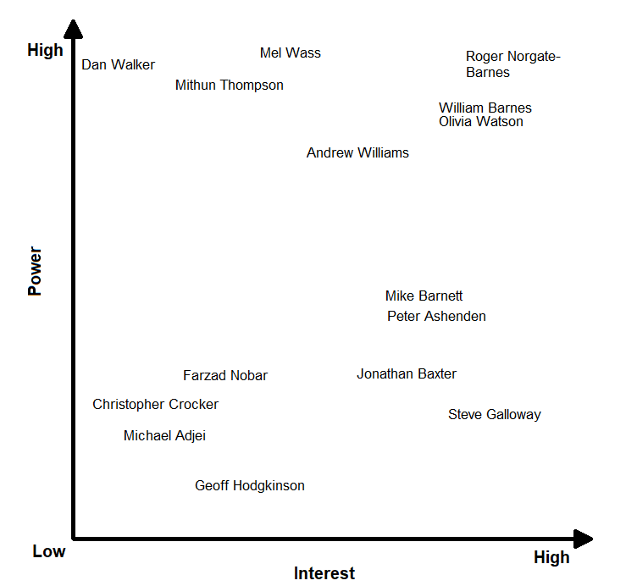

A discussion between myself and my team then occurred which showed

Revised list of key stakeholders:

|  |  |  |
| --- | --- | --- |
| Role | Name | Company |
| Product Owner Data Intelligence Suite | Mel Wass | SCCL |
| Product Owner Data Modeller | Andrew Williams | SCCL |
| Project Lead – SME | Mithun Thompson | DXC |
| Business Analyst | Roger Norgate-Barnes | DXC |
| Analyst | William Barnes | DXC |
| Analyst | Olivia Watson | DXC |
| Security and Support | Dan Walker | DXC |
| Savings Business Analyst | Mike Barnett | DXC |
| Savings Data Engineer | Peter Ashenden | DXC |
| CTRP Chief BI | Jonathan Baxter | DXC |
| Lead Business Analyst for CTRP | Steve Galloway | SCCL |

Revised prioritisation chart of these key stakeholders:

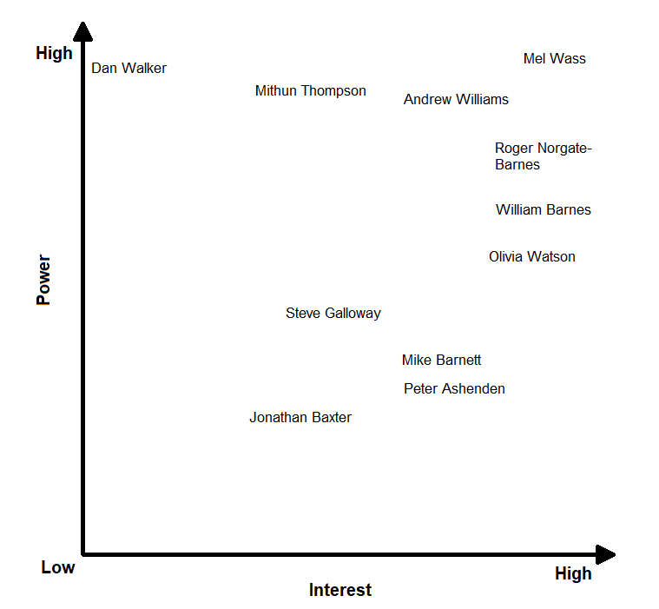

**erwin Key Stakeholders Communication Plan**

|  |  |  |
| --- | --- | --- |
| Name | Company | Communication Plan |
| Mel Wass | SCCL | Scrum and Sprint Meetings |
| Andrew Williams | SCCL | Scrum and Sprint Meetings |
| Mithun Thompson | DXC | Scrum and Sprint Meetings |
| Roger Norgate-Barnes | DXC | Scrum and Sprint Meetings |
| William Barnes | DXC | Scrum and Sprint Meetings |
| Olivia Watson | DXC | Scrum and Sprint Meetings |
| Dan Walker | DXC | Set up specific call when needed |
| Jatender Karra | DXC | Infrastructure related calls |
| Nigel Welham | DXC | Infrastructure related calls |
| Rob Coward | DXC | Infrastructure related calls |
| Mike Barnett | DXC | Savings specific calls |
| Peter Ashenden | DXC | Savings specific calls |
| Victor Sanchez | DXC | Savings specific calls |
| Jonathan Baxter | DXC | CTRP specific calls |
| Steve Galloway | SCCL | CTRP specific calls |
| Christopher Crocker | erwin | erwin Weekly Call |
| Farzad Nobar | erwin | erwin Weekly Call |
| Michael Adjei | erwin | erwin Weekly Call |
| Geoff Hodgkinson | erwin | erwin Weekly Call |
| Richard Tunks | SCCL | CTRP specific calls |
| Stuart Skeets | SCCL | Access specific calls |
| Andy Minshull | SCCL | Access specific calls |

Before meeting with stakeholders think:

* What information do I need from this meeting?
* How can I get that information?
* What information do I want to share with the stakeholder?

Then create an agenda for the meeting to gain access to these answers. Take meeting minutes and then write up and form a plan for next steps. Send this off to the stakeholders you’ve just been in touch with for their sign-off.

Remember:

* A good question is one that lets you obtain the type, quality, and quantity of information you need.
* Open ended questions encourage people to reflect and reveal what is important to them.
* Closed questions allow you to nail down a specific point.
* Never be afraid to ask a follow-up question if the first answer doesn’t tell you what you need to know.

These types of questions would be useful to think about when creating your list of questions to take to key stakeholders:

|  |  |  |
| --- | --- | --- |
| Type | Desired Outcome | Example |
| Explorative | Expand on new points of view and uncovered areas | Tell me more about…? |
| Affective | Reveal stakeholder’s feelings about something | How do you feel about…? |
| Probing | Invite a deeper examination | Can you describe how…? |
| Analytical | Find root of problem | What are the causes of…? |
| Clarifying | Help align and avoid misunderstandings | So, you mean that…? |

Create a question bank as an information resource. Have old previous questions and their answers, then new questions which are yet to be asked and identify the correct stakeholder to ask these questions to.

Have ready all the information you want to share with the stakeholder in the meeting – i.e., all relevant documents have been reviewed and are open and ready to share – preferably, if possible, send a copy of all documents you are hoping to discuss in an email ahead of the meeting, so the stakeholders have a chance to open them up and look over before the meeting.

**DXC Social Inclusivity App**

Key stakeholders with a RACI matrix:

|  |  |  |  |  |  |
| --- | --- | --- | --- | --- | --- |
| Name | Role | Responsible | Accountable | Consulted | Informed |
| Lee Joy | Talent Management | ✓ | ✓ | ✓ | ✓ |
| Astghik Stepanyan | People Manager Early Careers |  | ✓ | ✓ | ✓ |
| Cameron Shields | Technical Graduate |  |  | ✓ | ✓ |
| Justin Fallon | Head of Virtual First Transition |  |  | ✓ | ✓ |